Functional Diversity Educational Activity
Luke Bassett
12/4/2015

In order to help teach the public on the importance of teleost diversity and inform them of the various diversity indices used to study biodiversity, I plan on creating an interactive activity for Activity Days at the Virginia Institute of Marine Science and other local festivals. Originally this activity was going to focus on creating a functional dendogram or phylogenetic tree using stuffed animals, but after meeting with Karen Akerlof, Kathy Rowan, and Janet Krenn, I decided instead to change the activity to one involving laminated cards as. Studying characters in actual fish will allow students to learn more about Chesapeake Bay inhabitants. An individual or group will be given a set of cards each with a different fish on the front and some characteristics and functional traits on the back. They will then be asked to divide the cards into three to six groups based on appearance and/or functional traits listed. Likely, I will have younger individuals categorize fish purely by their appearance while older groups will use feeding, form and locomotion, size, and distribution characteristics as well. I may also have one group/individual categorize the fish purely based off the characteristics written on the back of the card while the other group/individual will categorize them based off individuals. I will then have the participants explain to me their reasoning behind their chosen grouping. After listening to them argue their explanations, I will explain the logic behind functional ecological groups and how they are determined as well as the fact they just created their own functional groups, albeit, in a simplified manner. Depending on where I am in my research, I will also show them the functional dendrogram that I have created with the fish used in the game highlighted.

Target Audience
My target audience will range from late elementary school students and their families to high school students. Younger students will focus more heavily on categorizing the fish based by appearances rather than traits listed.

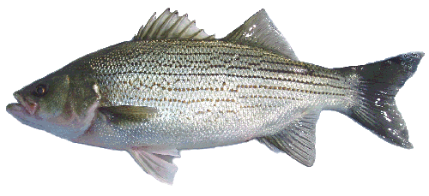  Striped Bass | Feeding – Feed on small fish and invertebrates.  Form and Locomotion – Fusiform body, sub-carangiform swimming  Size – 2 to 3 feet, 10 to 30 pounds.  Distribution – Live throughout the Bay. Spawn in freshwater and spend summer and winter in deep channels.
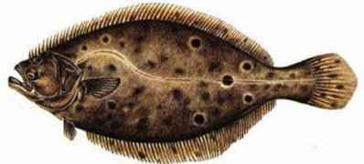  Summer Flounder | Feeding – Bottom feeder that eats small invertebrates and fish.  Form and Locomotion – Depressiform body, anal fin undulation  Size – 15 to 22 inches  Distribution – Adults are found in deep channels while young are found in shallower waters. Typically found in middle and lower Bay, but migrate offshore for winter.
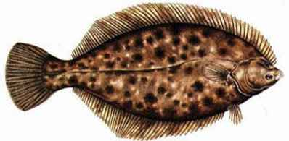  Winter Flounder | Feeding – Lie and wait predation on small crustaceans and worms.  Form and Locomotion - Depressiform body, anal fin undulation  Size – 6 to 8 inches  Distribution – Muddy bottoms throughout the Bay, except in summer months when they migrate to oceanic waters.
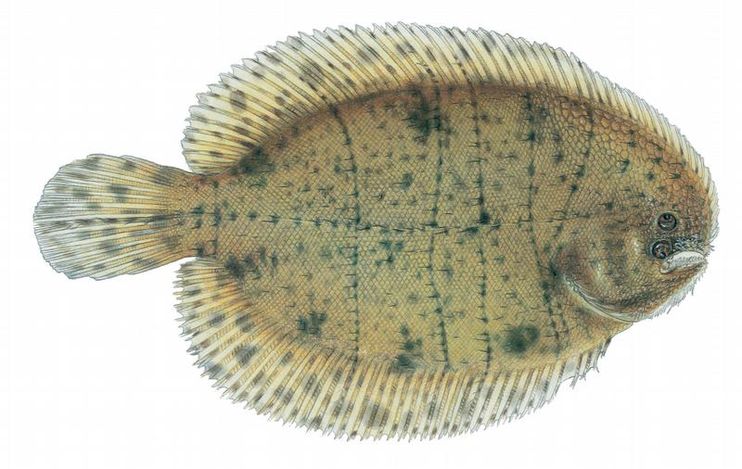  Hogchoker | Feeding – Lie and wait predation on small crustaceans and worms.  Form and Locomotion - Depressiform body, anal fin undulation  Size – 6 inches max  Distribution – Found throughout the Bay, year round.
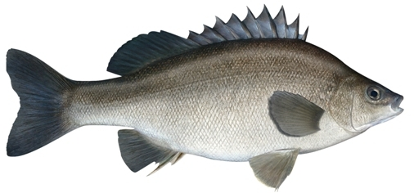  Silver Perch | Feeding – Small crustaceans and worms.  Form and Locomotion – Fusiform body, carangiform swimming.  Size – 9 inches max  Distribution – Middle and lower Bay, year round.
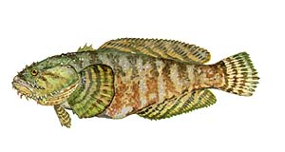  Oyster Toadfish | Feeding – Lie and wait predator. Eats small crabs and other crustaceans.  Form and Locomotion – Depressed body, paired fin propulsion.  Size – 12 inches max  Distribution – Bottom dweller around oyster reefs in the Bay. Move from shallows to deep channels in winter.
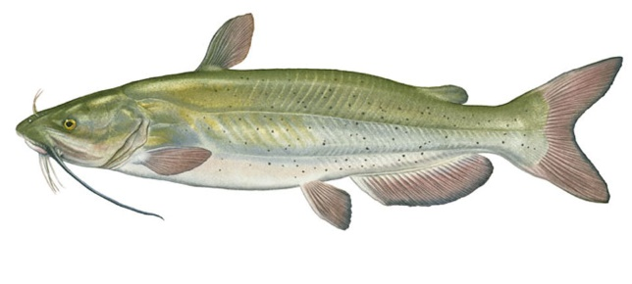  Channel Catfish | Feeding – Bottom feeders, diverse diet.  Form and Locomotion – Fusiform body, sub-carangiform swimming.  Size – 2 to 4 feet max, around 50 lbs max.  Distribution – Bottom dweller in fresh and brackish channel waters.
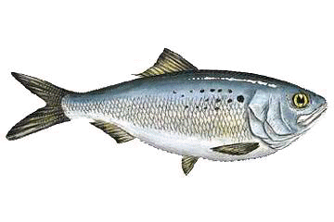  Atlantic Menhaden | Feeding – Filter feeder, zooplankton.  Form and Locomotion – Fusiform body, carangiform swimming.  Size – adults are 23 - 43 inches  Distribution – Found in shallow near shore waters throughout the Bay from spring to autumn.
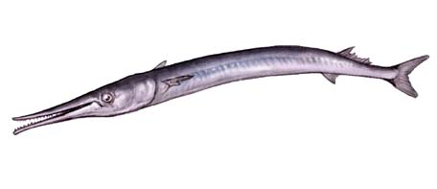  Atlantic Needlefish | Feeding – Forage feeder that eats small crustaceans and fish.  Form and Locomotion – anguilliform body and swimming.  Size – 14 to 18 inches  Distribution – Present in the bay from spring to fall.
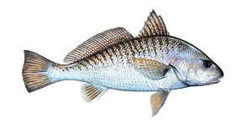  Atlantic Croaker | Feeding – Bottom feeder on small invertebrates and fish.  Form and Locomotion – Fusiform body and carangiform swimming.  Size – 18 to 20 inches.  Distribution – Migrates up the Bay in spring and towards the ocean in fall.
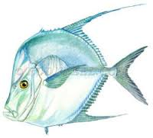  Lookdown | Feeding – Feeds on small worms, fish, and crustaceans.  Form and Locomotion – Compressiform body and carangiform swimming.  Size – 1 foot and 2-3 lbs.  Distribution – Present in lower Bay in summer to autumn.

Fish information found at:
Chesapeake Bay Program (20l1) Bay Field Guide. World Wide Web Electronic Publication. http://www.chesapeakebay.net/fieldguide, (12/2015)
Froese, R. and D. Pauly. Editors (2015) FishBase. World Wide Web electronic publication.
www.fishbase.org, (12/2015)

